**PROJECT NAME :**

***Measuring the pulse of prosperity : An index of economic***

***Freedom analysis***.

**TEAM MEMBERS:**

***Vigneshwari . R***

***Vijayalakshmi . M***

***Vijayatharshini . M***

***Sandhiya.B***

**PROJECT REPORT**

**INTRODUCTION:**

**OVER VIEW :**

***Economic freedom is the fundamental right of every human to control***

***his or her own labor and property . In an economically free society, individual***

***are free to work, produce, consume and invest in any way they please.***

***In economically free societies, governments allow labor, capital***

***to move freely labor, refrain from coercion or constrain of liberty beyond***

***the extent necessary to protect and maintain liberty itself.***

***An index of economic freedom measures jurisdictions against each other***

***in terms of parameters such as trade freedom, tax bur***

***den, judicial***

***effectiveness, and more. These factors may be weighted according to the***

***influence on economic freedom and compiled into a single score that***

***allows fora ranking.***

***The ranking can be done on a country basis or can look at wider***

***regionsor smaller subnational units like states.***

***The most widely referenced index of economic freedom is produced by***

***The heritage foundation, a conservative american think tank. The fraser***

***institute, a canadian think tank, also publishes a well-known index of***

***economic freedom.***

PURPOSE :

*Its help to understand the needs and preference of consumers and to identify opportunities for growth innovation .*

PROBLEM DEFINITION & DESIGN THINKING .

EMPATHY MAP :

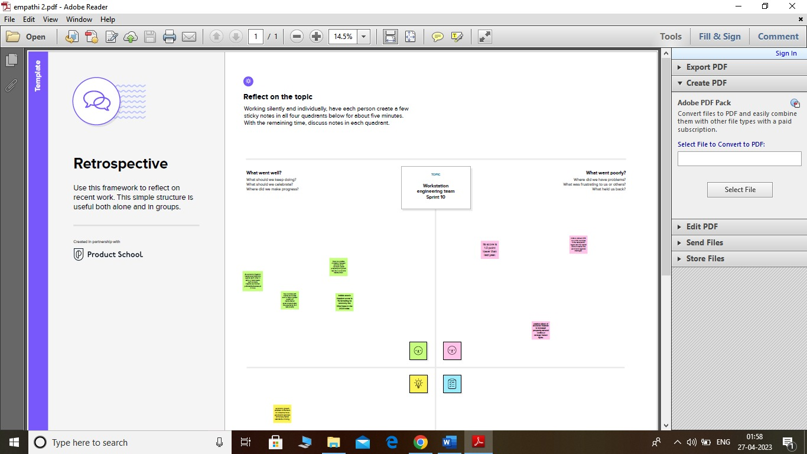

IDEATION & BRAINSTORMING MAP SCREENSHOT :

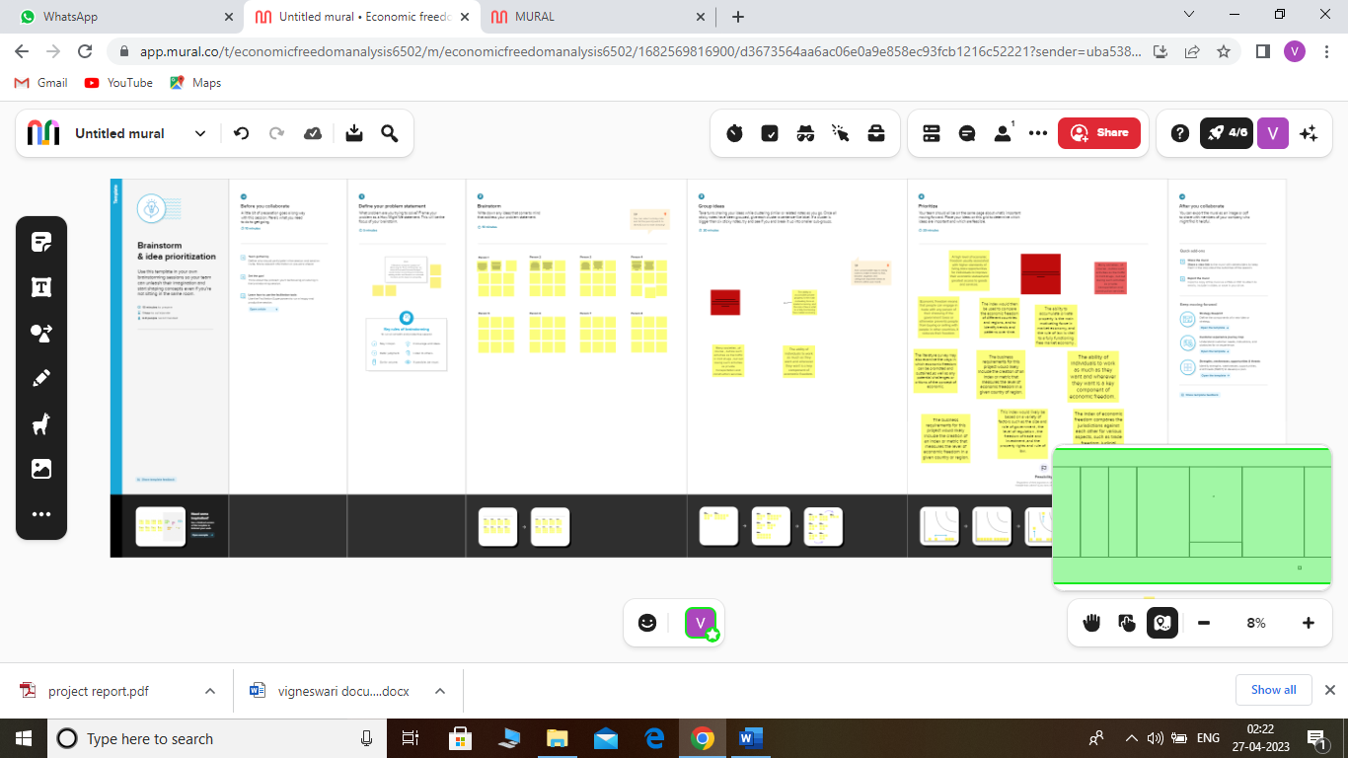

3 . RESULTS :

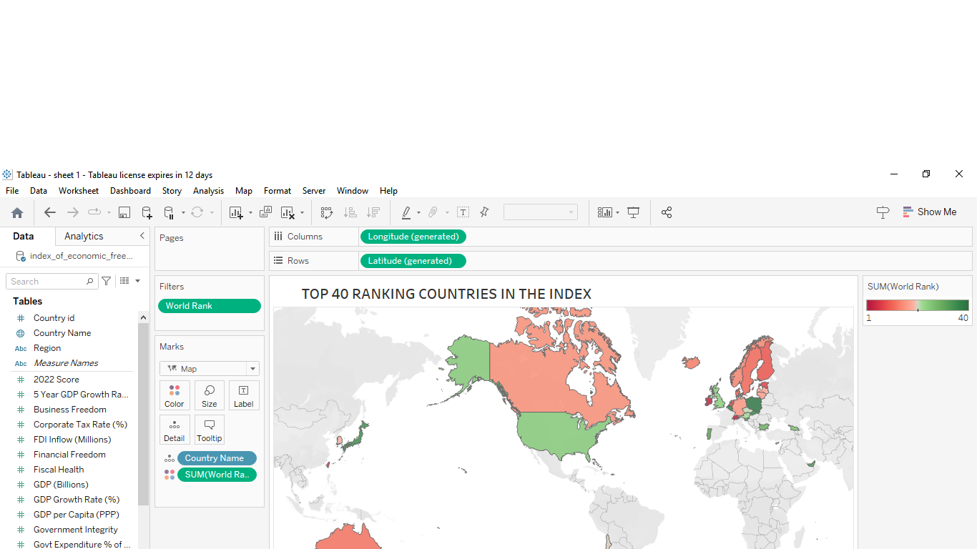

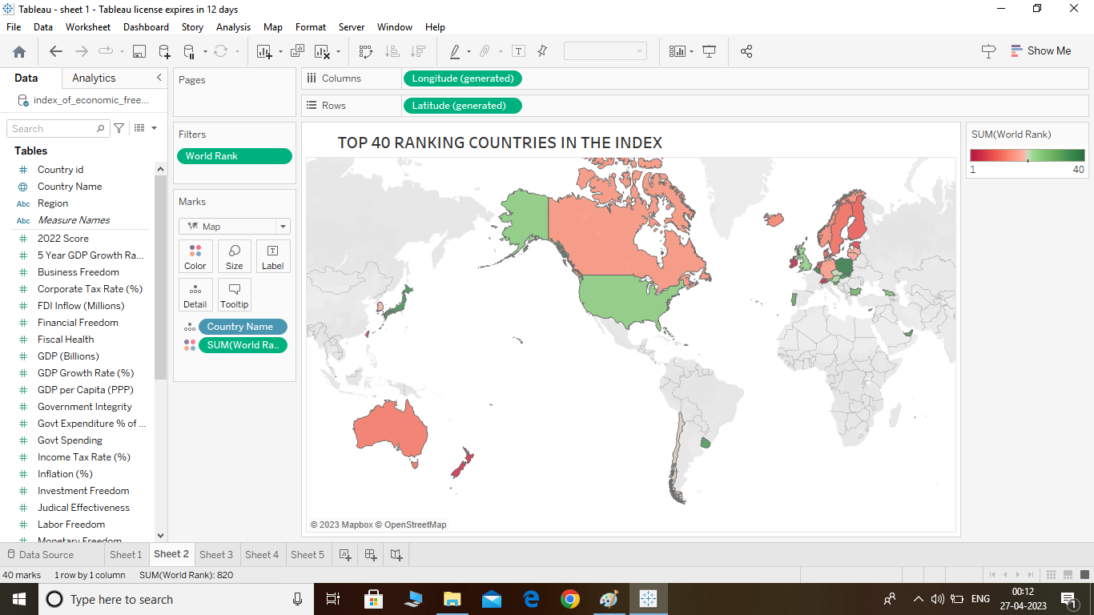

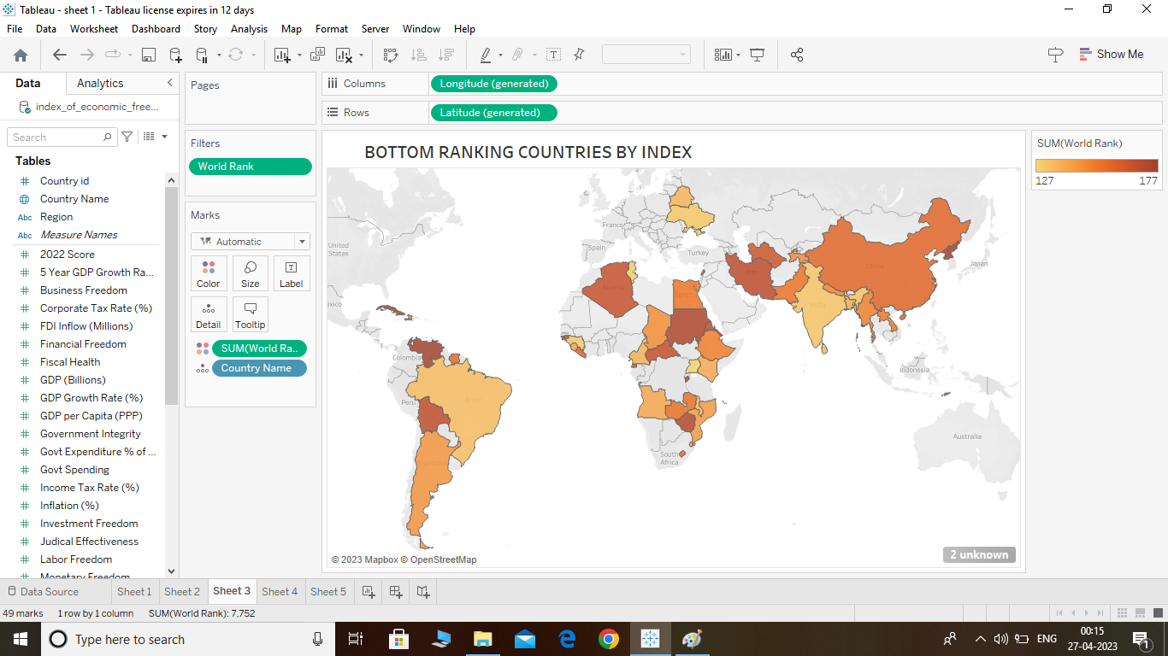

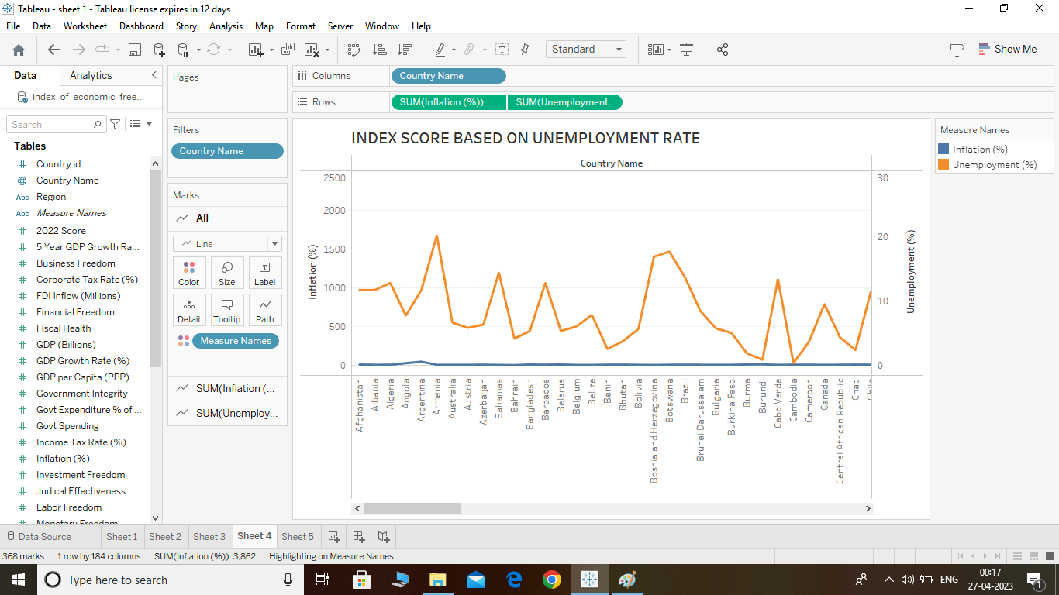

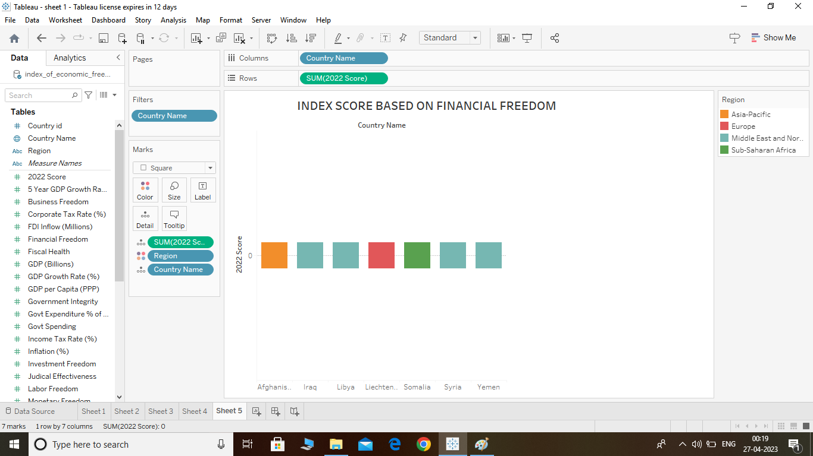

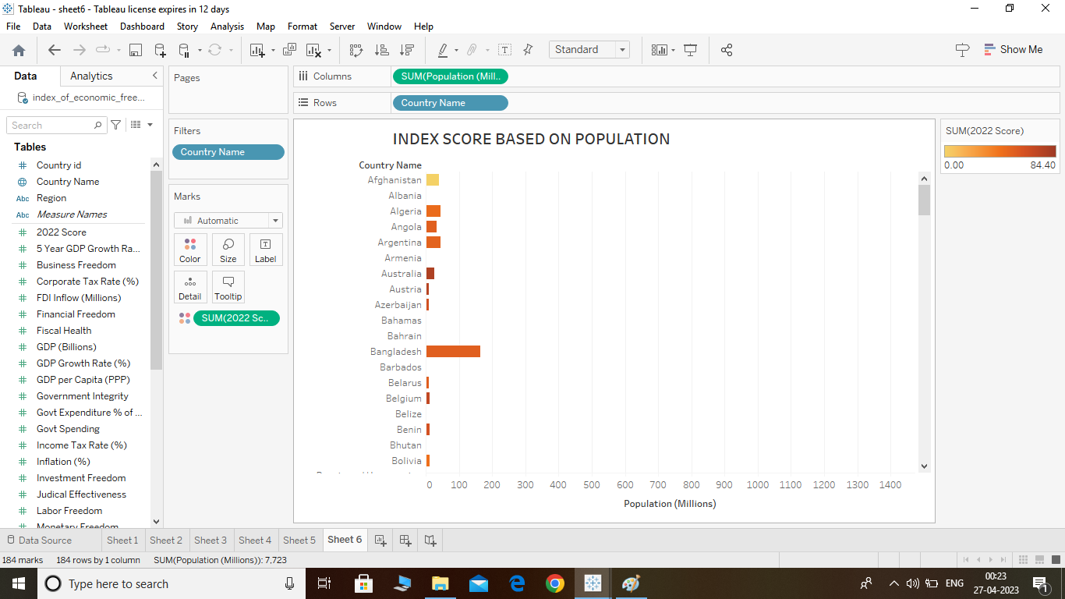

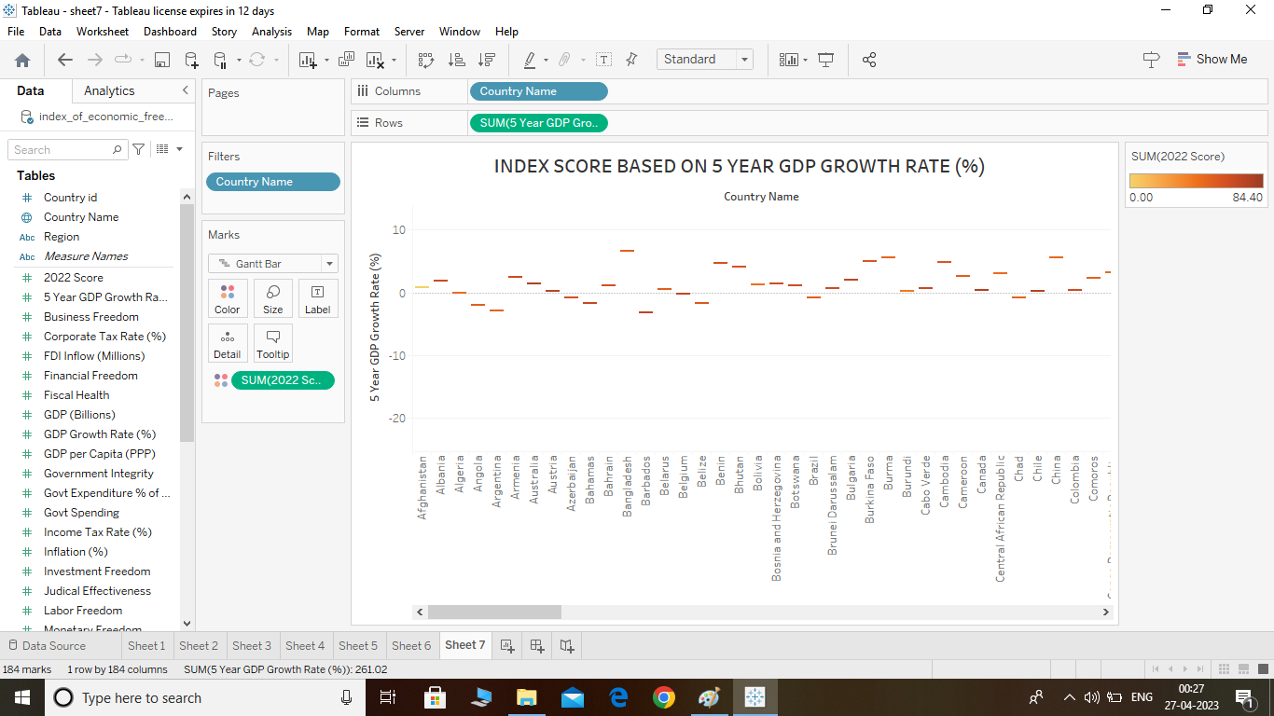

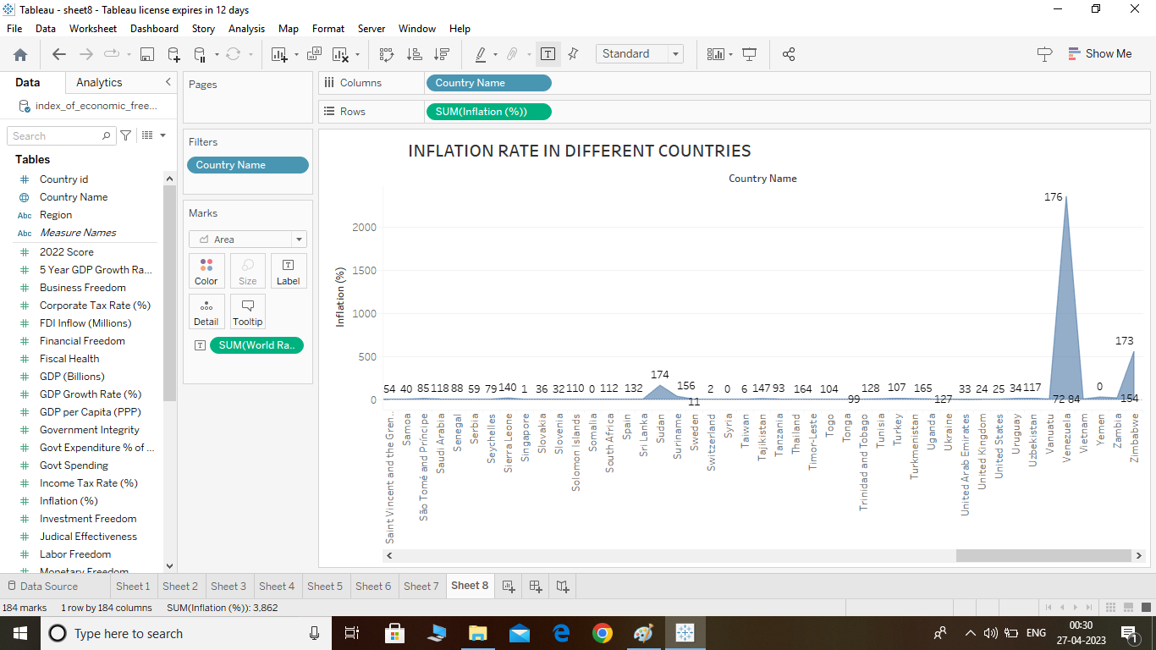

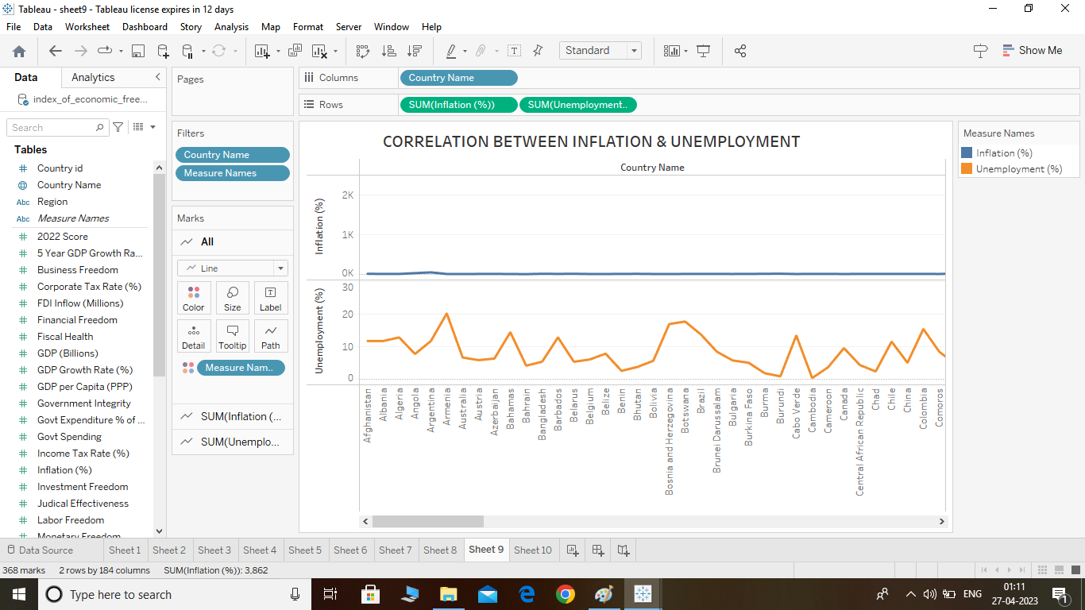

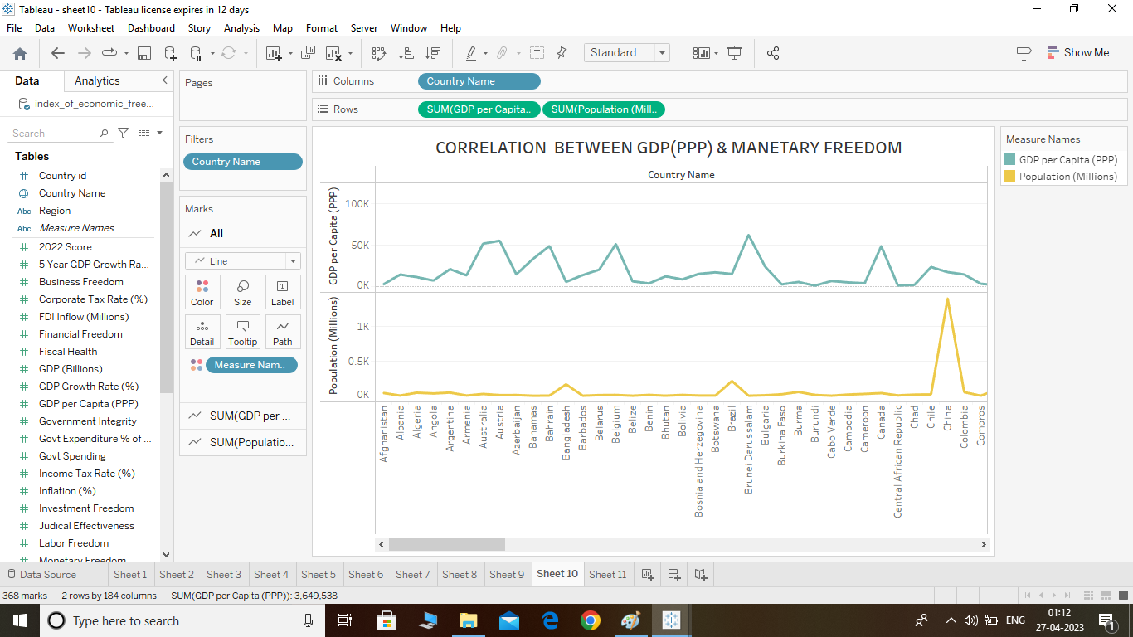

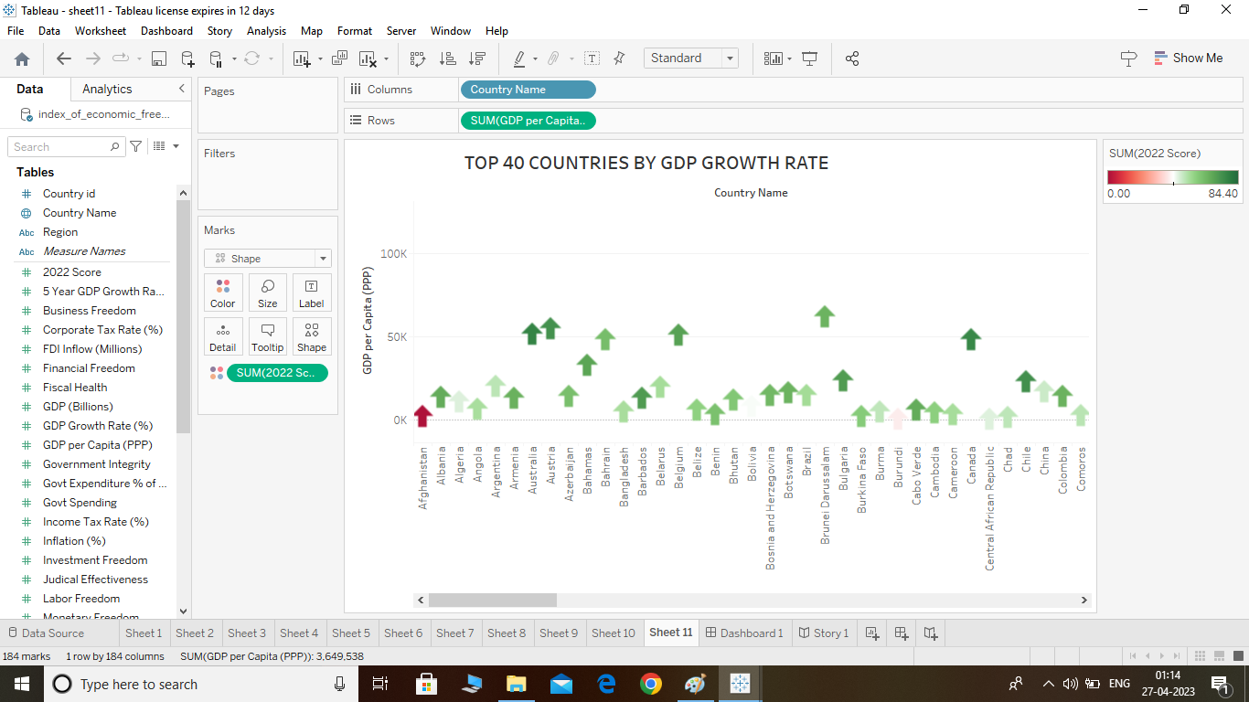

ADVANTAGES & DISADVANTAGES :

ADVANTAGES :

Free market economies allow business owners to innovate new ideas , develop new products and offer new services.

DISADVANTAGES :

Creates scarcity due to an inability to plan for individual needs . Eliminates market competition , resulting in a lack of innovation and advancement.

APPLICATIONS :

This data may include information about the economic of share market . once the data has been collected , it is typically analyzed using .

CONCLUSION :

Economic analysis is a useful tool for planning and evaluating prospects in changing management practice (s) , also in a close to subsistence farming economy

FUTURE HOPE :

The world economy could more than double in size by 2050. Far outstripping population growth , due to continued technology-driven productivity improvements . Emerging markets (E7) could grow around twice as fast as advanced economies (G7) on average .